PAGE ONE

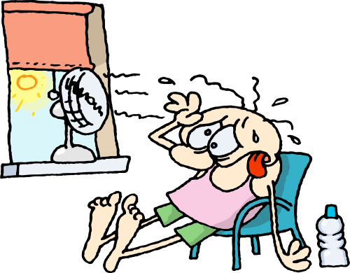
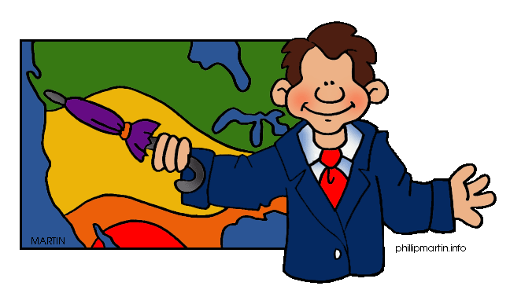
Contents:

- What is heat?
- How do we measure heat?
- What is temperature?
- Scales of measurement of temperature.
4.1- The Celsius Scale
4.2.- The Kelvin Scale
- What are the effects of heat?
5.1.- Contraction
5.2.-Expansion
- How does heat travel?
6.1.- Conduction
6.2.- Convection
6.3.- Radiation

Full name: …………………………………………………………………………………..
Date: ……………………………………………………………………………………………
Class: ………………………………………………………………………………..………..
School: ………………………………………………………………………………………..
Teacher: ………………………………………………………………………..……………

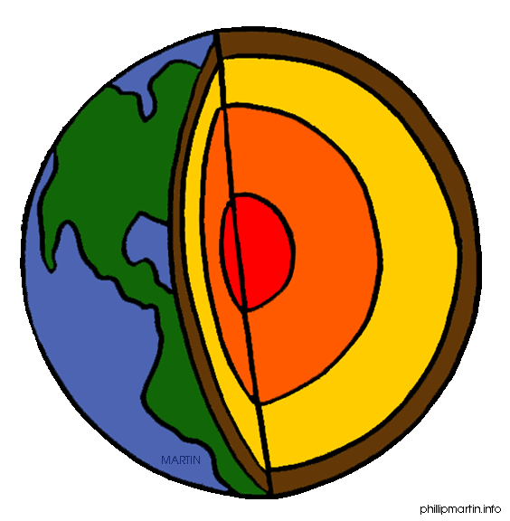

PAGE TWO
Vocabulary

A
- always: siempre
- another: otro/a

B
- behaviour: comportamiento
-boil: hervir
-boiled: hervido/a
-bowl: cuenco, recipiente

C
-
D
- decrease: disminuir
- due to: debido a

E
-

F
- flow: fluir, circular

G
-
H
- heat: calor
- heated: calentado/a
- higher: más alto/a

I
- increase: aumentar

J
-

K
-
L
- less: menos
- lower: más bajo/a
M
- matter: material
-mean: significar
- measure: medir
- measurement: medida
- most: la mayoría de

N
O
- occupy: ocupar

P
-
Q
- quickly: rápidamente
R
- release: liberar

S
- same: mismo/a
- slowly: lentamente
- source: fuente
T
- through: a través de

U
- until: hasta que

W
- what: qué, cuál, cuáles
- when: cuando
-which: que, el cual, la cual
X

Y

Z
-

PAGE THREE

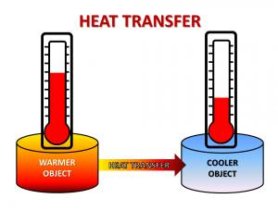
1.- What is heat?

Heat is the transfer of energy between two bodies that have different temperature. Heat always flows from a substance at a higher temperature to the substance at a lower temperature. One substance releases heat and the other absorbs it.

Thermal equilibrium is a state in which two objects reach the same temperature. When we put a potato boiled at 70ºC into a bowl of water at 10ºC, the potato transfers heat to the bowl of water until they have the same temperature.

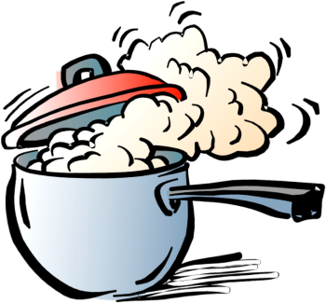
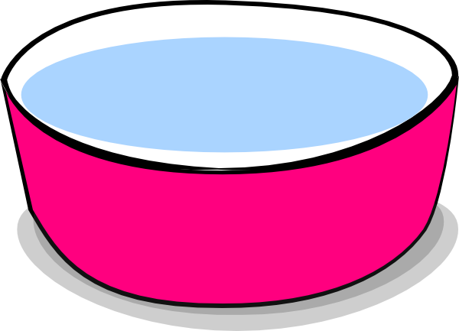

2.- How do we measure heat?

There are two units of measurement for heat. The joule (J) is the unit of measurement for the International System but the calorie is another unit of measurement. One joule is equal to 0.24 calories.

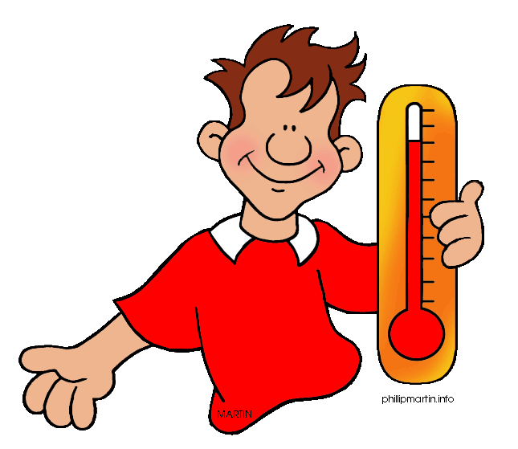
3.- What is temperature?

Temperature is the amount of heat in a system. Therefore, it is the magnitude of the heat. Heat and temperature are not the same. When one system releases heat, its temperature decreases. A thermometer is the tool that measures temperature. Most thermometers use liquids, which expand when they are heated. Mercury and alcohol are the most commonly used liquids in thermometers. Temperature of normal human body is 37ºC

PAGE FOUR

Activity one. Fill in the gaps with the words below. You can listen to the song in youtube if you click this link: https://www.youtube.com/watch?v=ZYuhMXmJeh4

cold same degrees measured sum kinetic

Heat and temperature are related but they are not the (1)___________. Heat is the (2)_________of all energy in a substance. Heat is (3)_____________ in joules (J) and heat transfers from hot to (4)___________.

A thermometer measures temperature in (5)___________. Temperature is a measure of the (6)_______________ energy of particles.



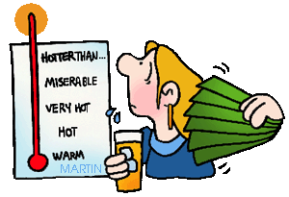

4.- Scales of measurement of temperature.

The main scales of measurement of the temperature are:

- The Celsius scale (ºC), also called centigrade. It is the most common. This scale is based on the behaviour of water. The freezing point of water is 0ºC and the boiling point is 100ºC.

- The Kelvin scale (K), also called absolute scale. It is the scale used by the International System. This scale is based on the behaviour of the matter.

5.- What are the effects of heat?

The effects are two:

- Contraction. This is the decrease in volume which occurs when a system loses heat. The particles move slowly and they occupy less space.

- Expansion. This is the increase in volume which occurs when a system gains heat. The particles move quickly and they occupy more space.

PAGE THREE
6.- How does heat travel

Heat can be transferred from one place to another by three methods: conduction, convention and radiation.

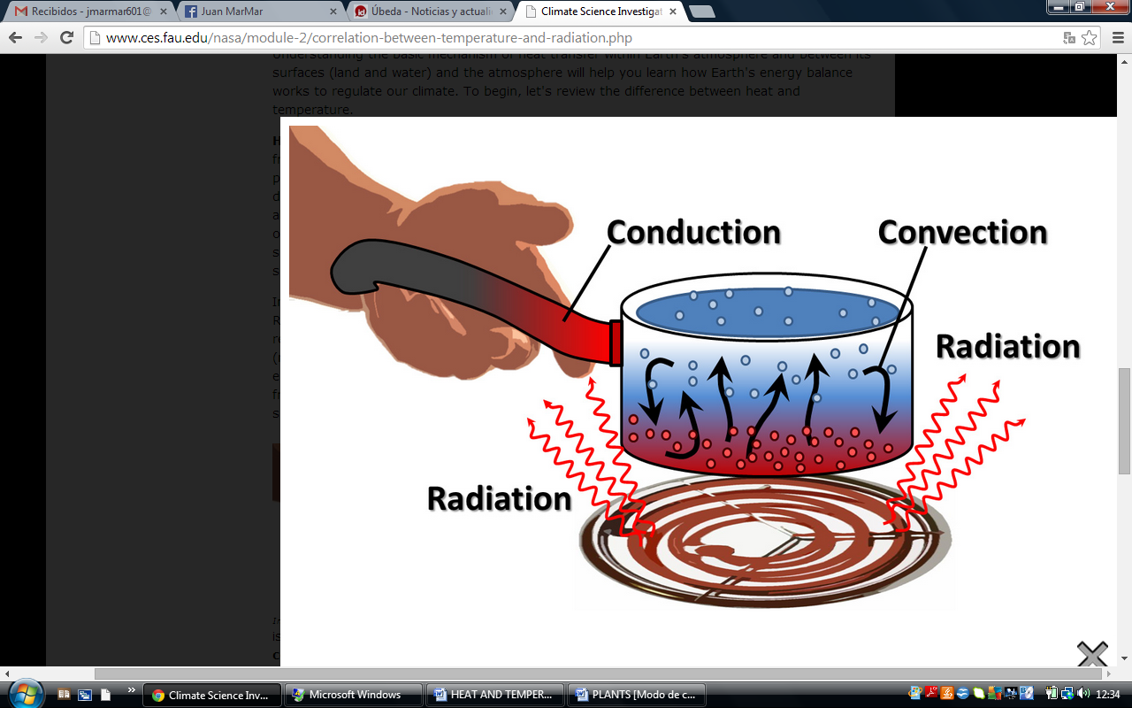
- Conduction. It occurs in most solids. Heat is transferred by direct contact. Heat flows from the warmer part of an object to the cooler part of an object. The heat flow stops when the body reaches the same temperature.

- Convection. It occurs in liquids and gases. Heat is transferred by the movement of particles. They are produced when there is a difference of density between a warm liquid and a cold liquid or between warm gases and cold gases.

- Radiation. it is the transfer of heat by electromagnetic waves. No contact is necessary between the source and the heated substance. It is the fastest form of heat transfer

Activity two. Are these statements TRUE or FALSE.
Correct the false ones:

1.- The Kelvin scale is based on the behaviour of water. ______ _________________
_________________________________________________________________________
2.- Convection is the fastest form of heat transfer. ______ ______________________
_________________________________________________________________________
3.- Convection occurs when there is a difference in density. ______ _____________
_________________________________________________________________________
4.- Electromagnetic waves are responsible for conduction. ______ _______________
_________________________________________________________________________

Activity three. Finish the sentence in a logical manner.
1.- When a system loses heat the effect of heat is called ________________________
2.- Expansion means that particles __________________________________________
_________________________________________________________________________
3.-The Kelvin Scale is based_________________________________________________
4- The movement of particles is the responsible for ____________________________
5.-The combination of warm and cold liquids produce __________________________

